Q.1 Install Power BI Desktop and share the final Screenshot of the report view page which appears when power desktop starts.
Answer:
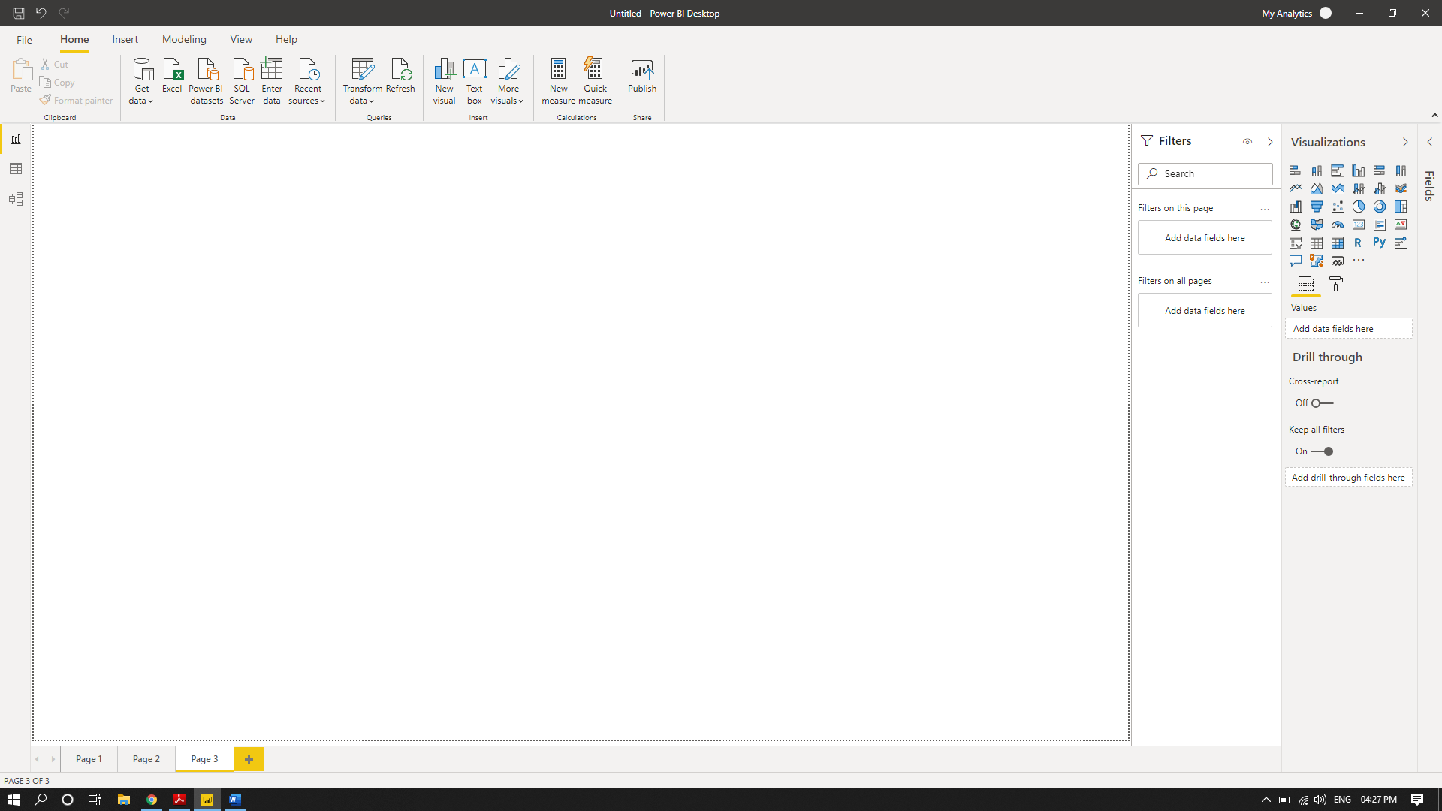

Quest. Prepare a document and with the following screenshot:
Answer:
Report View:
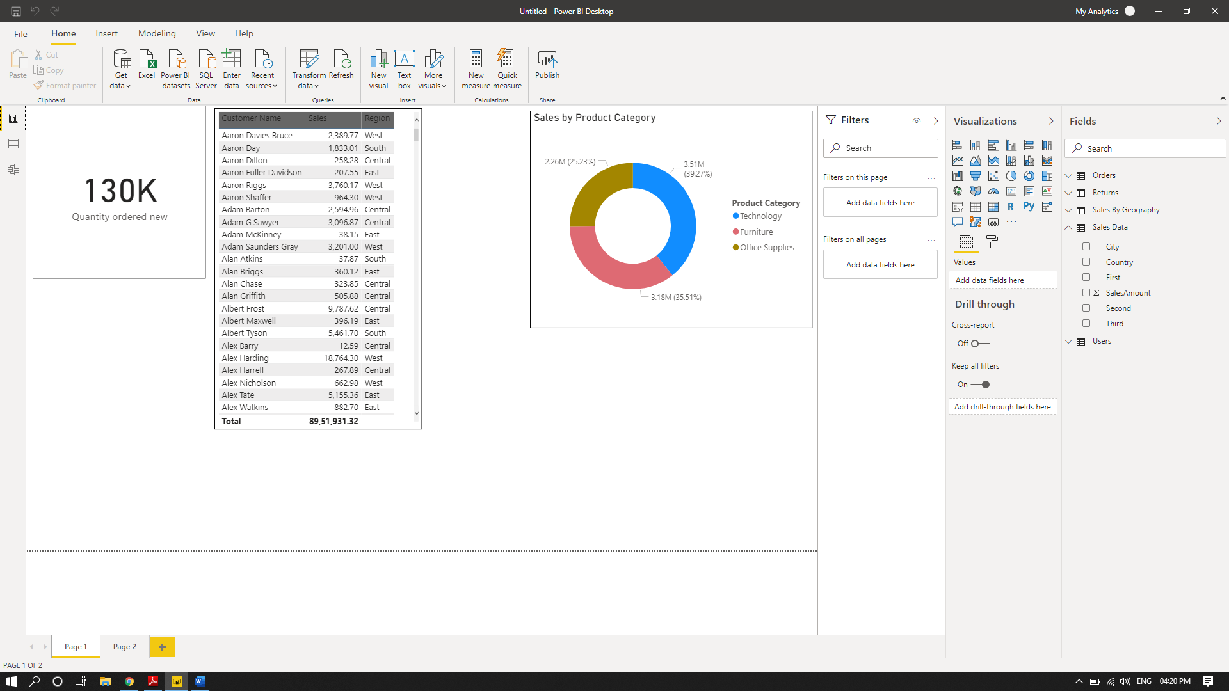

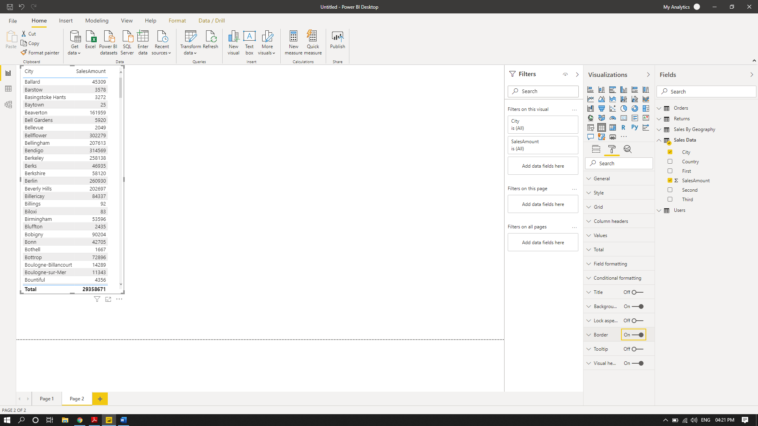

Data View:
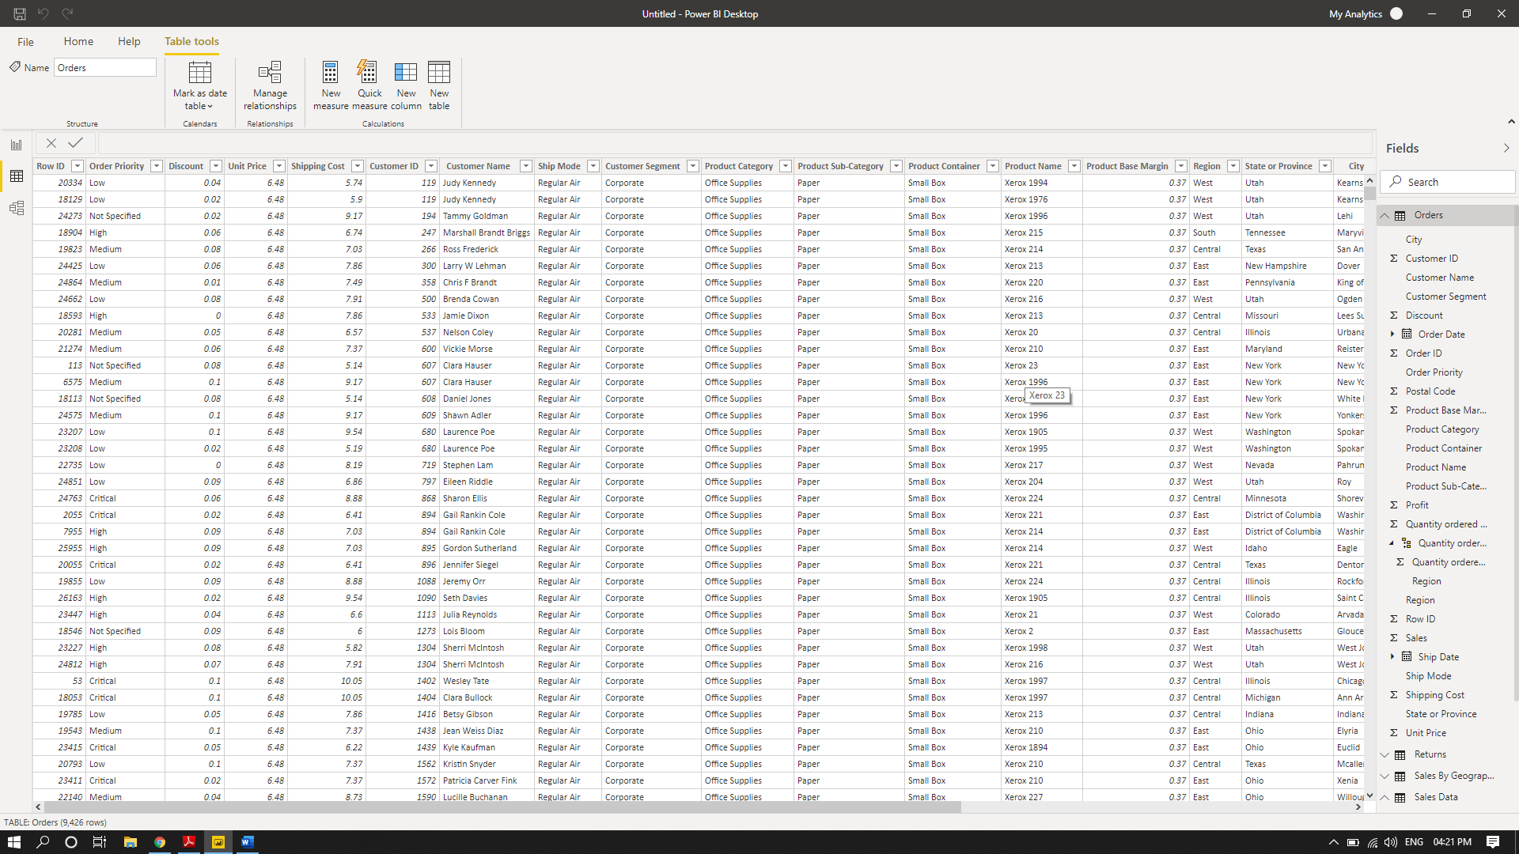

Model View:
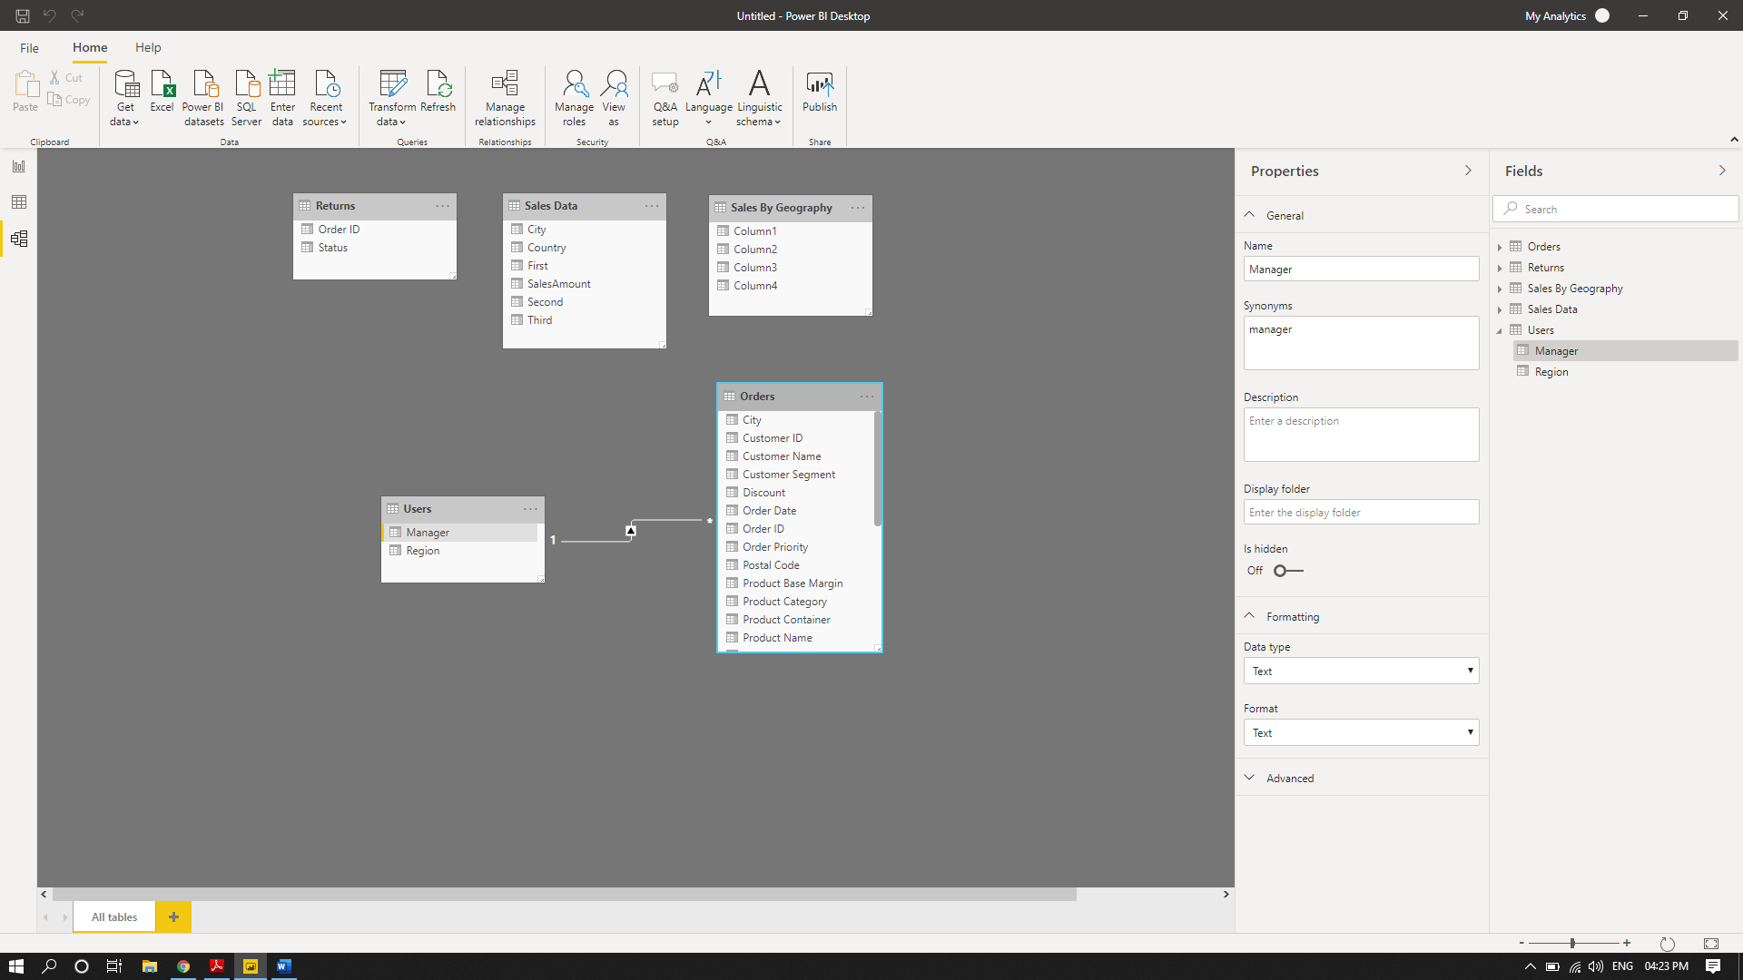

Power Query Editor:
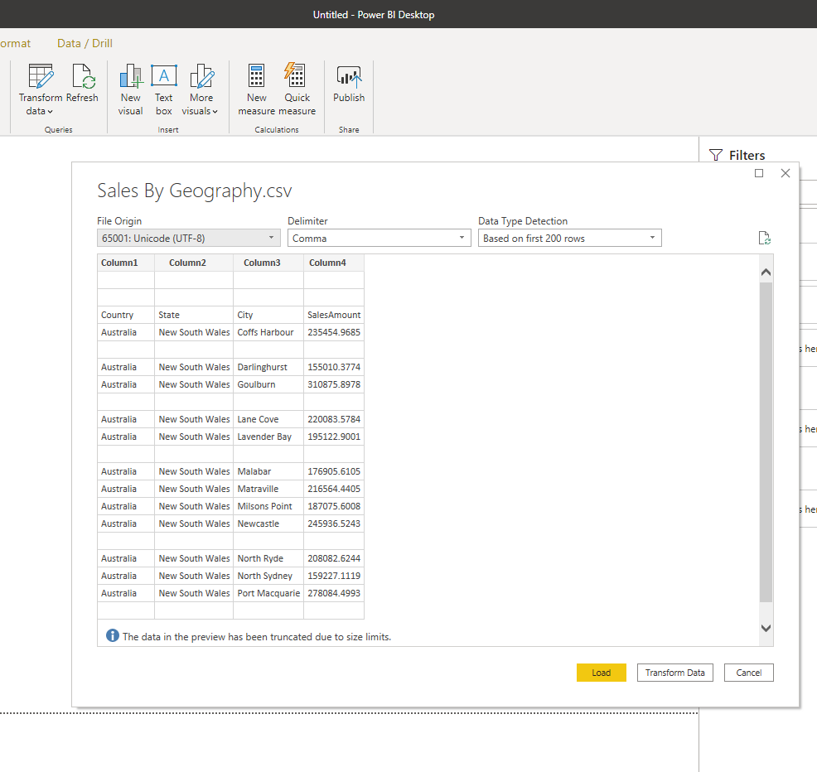

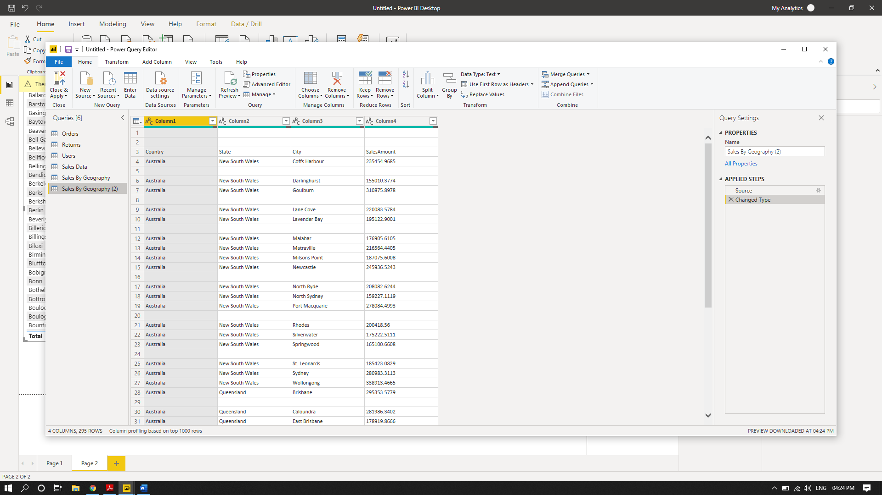

Advance Editor:
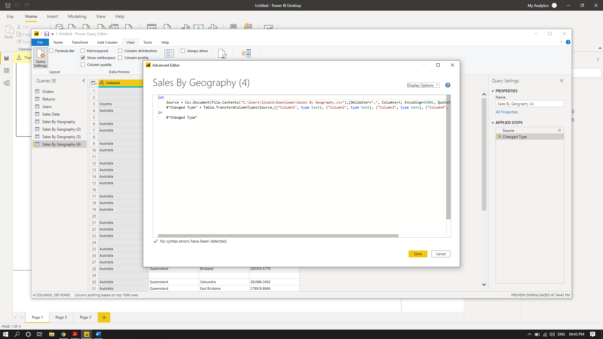

Q.3:Prepare a document with the details of the following along with their price.
- Power BI Desktop
- Power BI Pro
- Power BI Premium

Power BI Desktop:
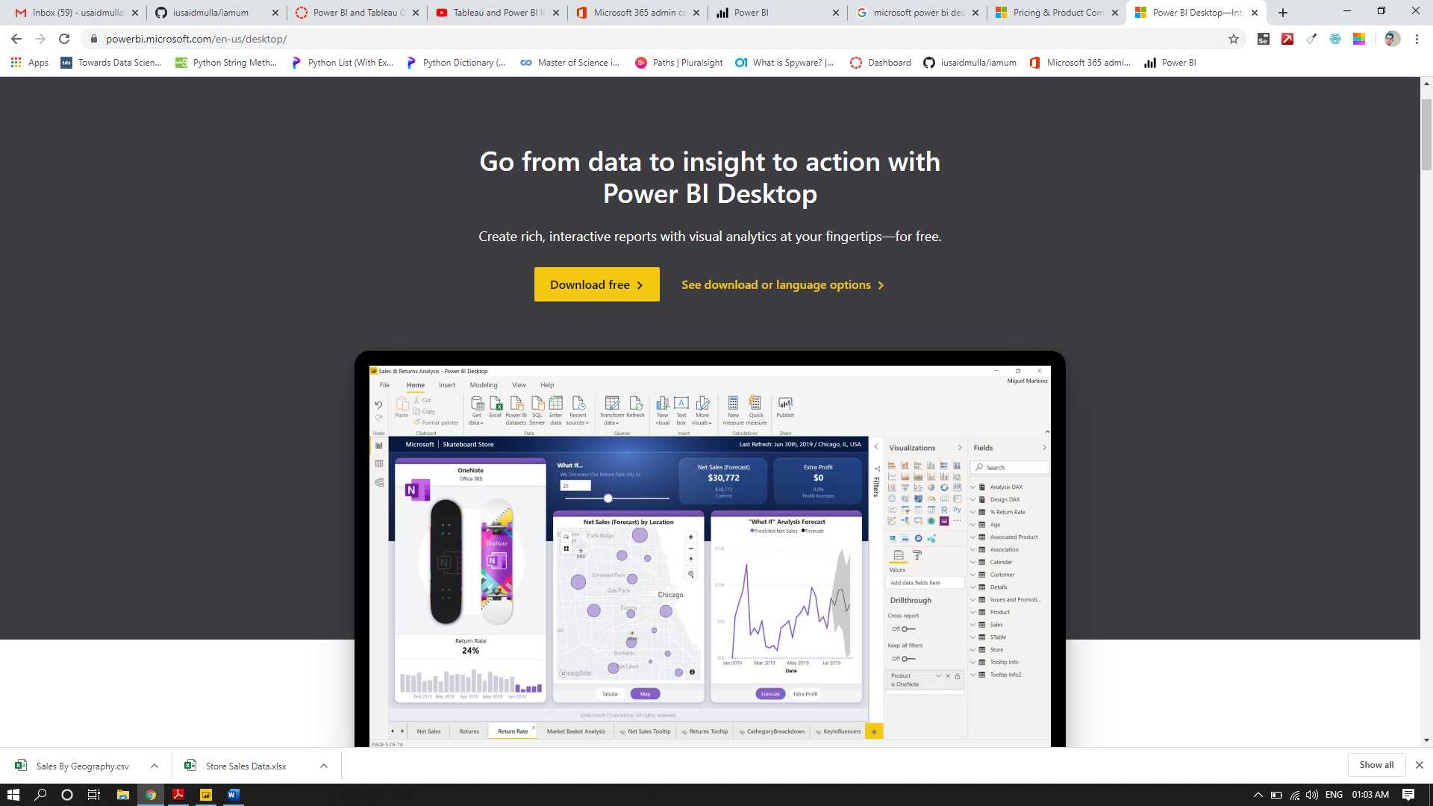

Connect to your data, wherever it is
Access data from hundreds of supported on-premises and cloud-based sources, such as Dynamics 365, Salesforce, Azure SQL DB, Excel, and SharePoint. Ensure it’s always up to date with automated, incremental refreshes. Power BI Desktop enables you to develop deep, actionable insights for a broad range of scenarios.

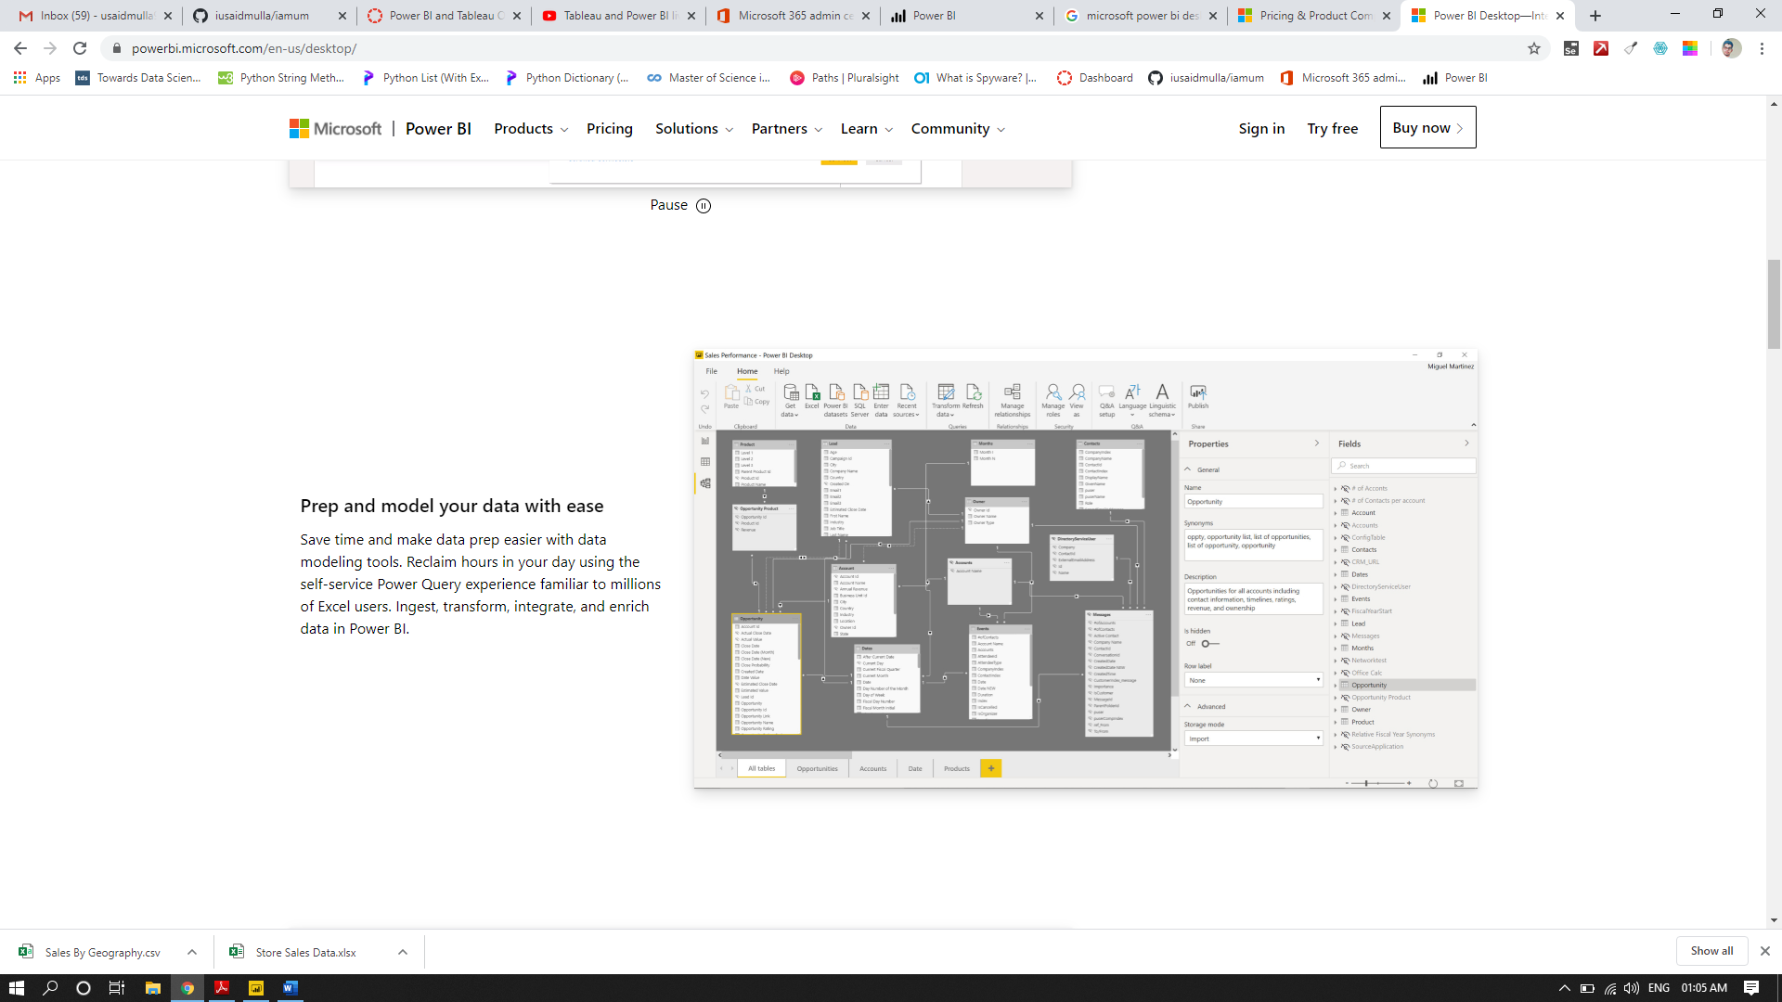

Prep and model your data with ease
Save time and make data prep easier with data modeling tools. Reclaim hours in your day using the self-service Power Query experience familiar to millions of Excel users. Ingest, transform, integrate, and enrich data in Power BI.
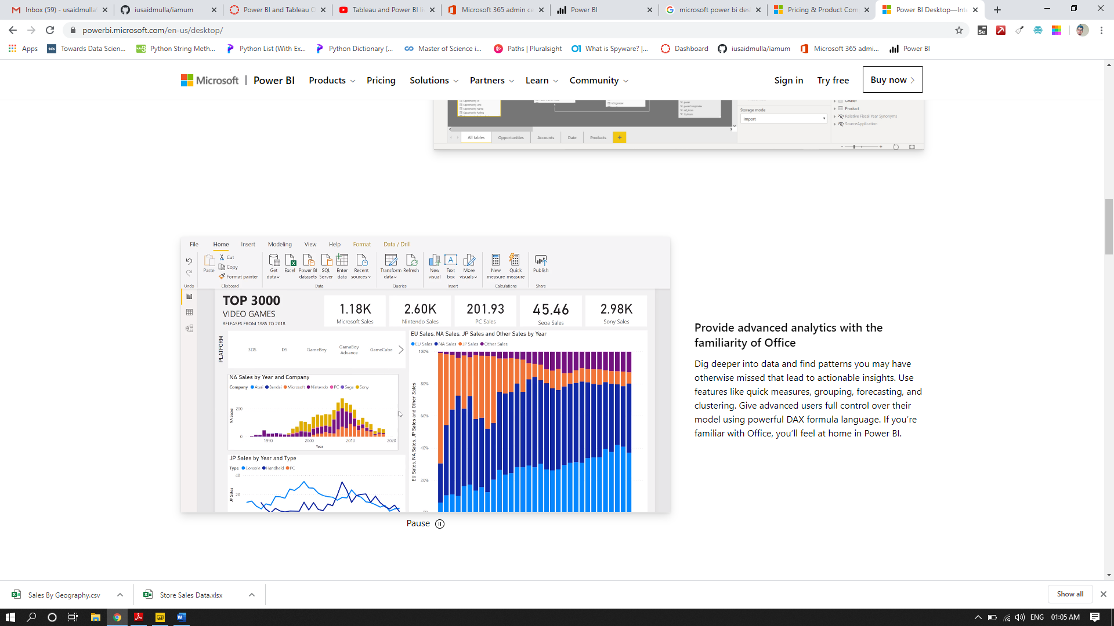

Provide advanced analytics with the familiarity of Office
Dig deeper into data and find patterns you may have otherwise missed that lead to actionable insights. Use features like quick measures, grouping, forecasting, and clustering. Give advanced users full control over their model using powerful DAX formula language. If you’re familiar with Office, you’ll feel at home in Power BI.

- Power BI Pro
- Power BI Premium

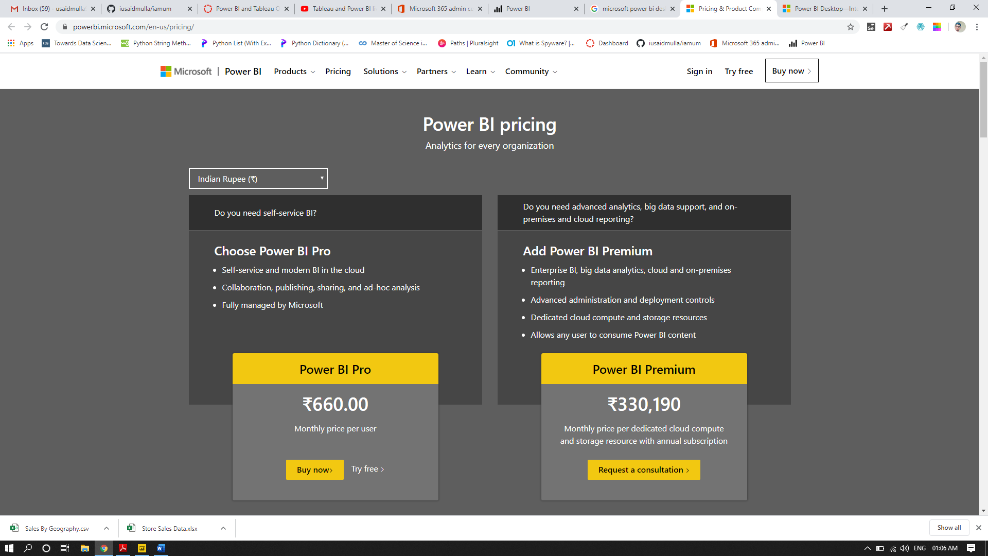

Power BI Pro
The biggest difference between Free and Pro is that with Pro you can share your data, reports, and dashboards with other users who also have a Power BI Pro license. You can also create App workspaces. Both Power BI Free and Pro have a 10 GB per Pro user data storage limit. Here is a screenshot from Microsoft’s Power BI website that summarizes the difference.

Power BI Premium
Power BI Premium is an on-premise deployment and distribution of Power BI reports using the Power BI Report Server. This allows you to maintain reports on-premise and move to the cloud when your organization is ready.
Power BI Premium is designed to address the challenges of large enterprise deployments and workloads. It enables your organization to use your own dedicated capacity and hardware rather than relying on Microsoft’s shared capacity. You’ll need to provide that capacity and ensure you have enough for your reporting and analysis purposes. This allows for much larger scale and better performance if you size it properly. Microsoft offers three sizes for Premium capacity and each come with a different number of v-cores and memory size. If you want to learn, check out this Microsoft blog about Power BI Pro vs. Power BI Premium.

